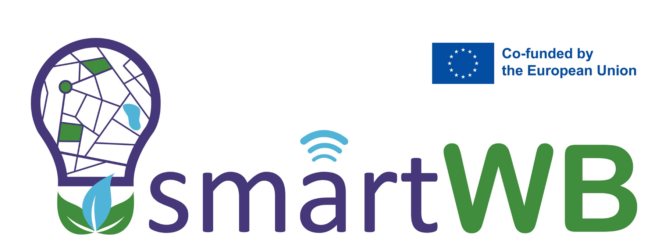

TASK 5.3 Posting of acquired best-practice examples in CSUD

This project has been funded by the European Union. Views and opinions expressed are
however those of the author(s) only and do not necessarily reflect those of
the European Union or the European Education and Culture Executive Agency (EACEA).
Neither the European Union nor EACEA can be held responsible for them.

Curricula innovation in climate-smart urban development based on green
and energy efficiency with the non-academic sector

Project: 101081724 — SmartWB — ERASMUS-EDU-2022-CBHE

PROJECT INFO
Project title | Curricula innovation in climate-smart urban development based on green and energy efficiency with the non-academic sector
Project acronym | SmartWB
Project reference number | 101081724
Funding scheme | Lump sum grant ‐ ERASMUS‐EDU‐2022‐CBHE
Web address | www.smartwb.ucg.ac.me
Coordination institution | University of Montenegro
Project duration | 36

DOCUMENT CONTROL SHEET
Work package | WP5 Implementation of modernized courses and platform
Ref. no and title of activity | T5.3 Posting of acquired best-practice examples in CSUD
Title of deliverable | Smart and Sustainable Wastewater Management: Innovations, Challenges, and Future Directions
Lead institution | NMBU
Author(s) | Harsha Ratnaweera, Rasha Hassan
Reviewer(s)
Document status | First Draft
Document version and date
Dissemination level | Sensitive

VERSIONING AND CONTRIBUTION HISTORY
Version | Date | Revision description | Partner responsible

Table of Content
Objectives of the article/post 1
Content Summary: 1
Key Takeaways: 2
Impact on the target audience 3
Attachments: 3

Title: Smart and sustainable wastewater management: Innovations, challenges, and future directions
Type: e-learning module
Author(s): Harsha Ratnaweera, Rasha Hassan
Date: 24-03-2025
Target Audience: Academics and researchers, urban planners and municipal authorities, water professionals, policymakers and legislators, and the non-academic sector.

Objectives of the article/post
This presentation is designed to foster a sustainable and efficient approach to wastewater management, tackling both current challenges and anticipating future needs. The objectives are as follows:
- To explore innovative strategies for holistic wastewater management to optimize sewerage systems and improve treatment efficiency.
- To advance sustainable wastewater treatment by addressing key challenges to transform wastewater treatment plants into hubs for energy production and circular resource management.
- To assess the role of digitalization in wastewater and stormwater management.
- To examine the impact of legislative frameworks in driving municipalities and industries toward sustainable urban development.

Content Summary:
Wastewater management is at the core of urban sustainability, public health, and environmental protection. As cities expand and climate change intensifies challenges such as extreme precipitation, sewer overflows, and pollution, traditional approaches to wastewater treatment are no longer sufficient. This presentation explores the transition from conventional treatment methods to holistic, smart, and climate-resilient wastewater management strategies, emphasizing digitalization, policy evolution, and resource recovery.
Historically, wastewater treatment has evolved through various approaches, from dilution-based pollution control to end-of-pipe treatment and cleaner industrial technologies. The European Union’s Urban Wastewater Treatment Directive (UWWTD) has played a crucial role in ensuring proper wastewater collection and treatment, with requirements for secondary and advanced treatment in urban areas. However, persistent challenges such as sewer overflows, industrial discharges, and climate-related vulnerabilities necessitate a more integrated approach.
A major transformation in wastewater management is being driven by smart technologies and digital solutions. Traditional wastewater treatment plants (WWTPs) often rely on outdated infrastructure and limited incentives for capacity expansion. With increasing rainfall events and urban flooding, the need for intelligent monitoring and adaptive management is growing. Digital tools now enable real-time analytics, predictive maintenance, and proactive decision-making, enhancing efficiency and resilience in wastewater systems. Smart solutions such as remote monitoring, combined sewer overflow management, and sensor-driven optimization are redefining how wastewater is collected, treated, and reused.
Regulatory frameworks have a critical influence on wastewater management practices. The recent recast of the EU UWWTD aims to address gaps in pollution control, requiring municipalities to take broader responsibility for total pollution loads rather than focusing solely on wastewater treatment plants. This shift encourages investments in sewer rehabilitation, stormwater management, and advanced treatment solutions. Smart legislation is also driving WWTPs to report bypass discharges and optimize phosphorus removal, incentivizing sustainable infrastructure upgrades.
Beyond pollution control, wastewater is increasingly recognized as a valuable resource. Modern approaches advocate for wastewater treatment plants to function as resource recovery centers, producing biogas, reclaiming water for reuse, and extracting nutrients such as phosphorus for agricultural applications. Addressing emerging micropollutants and optimizing resource recovery align with global sustainability goals, making wastewater management a key contributor to the circular economy.
The transition towards smart and holistic wastewater management is essential for ensuring water security, mitigating climate change impacts, and promoting sustainable urban development. By integrating digitalization, policy reforms, and resource recovery strategies, cities can build more resilient and efficient wastewater systems. The continued evolution of wastewater management will depend on collaboration between policymakers, industries, and researchers, fostering innovation in climate-smart urban planning and sustainable water governance.

Key Takeaways:
- Traditional wastewater treatment methods are insufficient to meet the growing challenges posed by climate change, urban expansion, and emerging pollutants. A forward-looking approach to wastewater management is needed to address both current challenges and anticipate future needs.
- Modern wastewater treatment goes beyond pollution control by promoting resource recovery. Wastewater treatment plants can function as resource hubs, generating energy (biogas), reclaiming water for reuse, and extracting valuable nutrients like phosphorus.
- Increased precipitation and extreme weather events are straining existing wastewater infrastructure. Smart wastewater treatment plants (WWTPs) and nature-based solutions, such as stormwater retention systems, are practical and cost-effective in these cases.
- The adoption of digital tools, such as real-time monitoring, predictive analytics, and intelligent wastewater network management, enhances treatment efficiency, reduces overflows, and supports proactive decision-making in wastewater management.
- Regulatory frameworks, such as the EU Urban Wastewater Treatment Directive (UWWTD), are evolving to address pollution holistically, requiring municipalities to take greater responsibility for total pollution loads and encouraging infrastructure improvements.
- Collaboration between academic and non-academic sectors is essential for driving curriculum innovation and implementing climate-smart urban development practices.
- Expanding the capacities of WWTPs and building supplementary treatment facilities are necessary to manage rainwater and reduce bypass discharges. Reporting discharge results, including bypasses, is vital for improving overall management.

Impact on the target audience
This document serves as a guide for various stakeholders, offering practical knowledge and strategic direction for improving wastewater management through innovation, regulation, and sustainability-driven solutions.

Attachments:
[Link to the full e-learning module, case study, video tutorial, White paper, research activity, policy document, environmental study, guidelines etc.]

