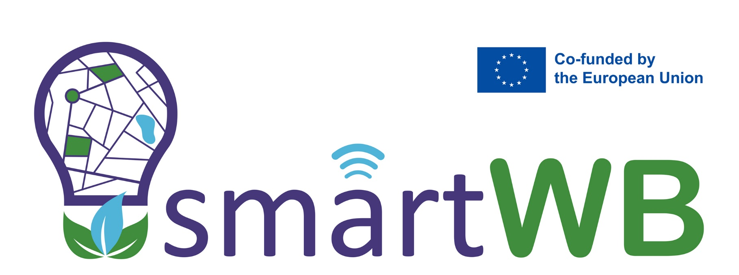

**COURSE TEMPLATE ON XXXXXX**

**GRADE/MASTER IN XXXXXX**

This project has been funded by the European Union. Views and opinions expressed arehowever those of the author(s) only and do not necessarily reflect those ofthe European Union or the European Education and Culture Executive Agency (EACEA).Neither the European Union nor EACEA can be held responsible for them.

Curricula innovation in climate-smart urban development based on greenand energy efficiency with the non-academic sector

Project: 101081724 — SmartWB — ERASMUS-EDU-2022-CBHE

|  |  |
| --- | --- |
| **PROJECT INFO** | |
|  |  |
| Project title | Curricula innovation in climate-smart urban development based on green and energy efficiency with the non-academic sector |
| Project acronym | SmartWB |
| Project reference number |  |
| Funding scheme |  |
| Web address | www.smartwb.ucg.ac.me |
| Coordination institution |  |
| Project duration | 36 |

|  |  |
| --- | --- |
| **DOCUMENT CONTROL SHEET** | |
|  |  |
| Work package | WP3 Capacity building of WB HEIs |
| Ref. no and title of activity | T3.1 Modernization of university courses in collaboration with the industry sector |
| Title of deliverable | D3.1. Report on modernized university courses |
| Lead institution | URJC |
| Author(s) | Carmen de Pablos-Heredero & Miguel Blanco-Callejo |
| Document status | Final Draft |
| Document version and date | V1 (08/03/2023) |
| Dissemination level | Public |

|  |  |  |  |
| --- | --- | --- | --- |
| **VERSIONING AND CONTRIBUTION HISTORY** | | | |
|  |  | | |
| Version | Date | Revision description | Partner responsible |
| v.01 | 8th March, 2023 | First template | URJC |
| v.02 | 19th June 2023 |  | THOWL |
| v.03 | 27th June 2023 |  | NMBU |
|  |  |  |  |
|  |  |  |  |
|  |  |  |  |

|  |  |
| --- | --- |
| **WATER PROTECTION I** | |
| Type | Compulsory |
| Teaching period | Master course, III semester |
| ECTS credits | 5 |
| Language | Bosnian |

|  |
| --- |
| **II. Presentation** |
| The main objective of this course is to acquire basic knowledge about the characteristics of natural waters, changes in water conditions, causes of changes, and water protection activities, measures and plans. Understanding the importance and application of an integral approach in the protection of water resources. Independent analysis of the state of water resources, and application of mathematical modeling as a tool for forecasting and solving problems in water protection. |

|  |
| --- |
| **III. Competences** |
| **Generic competences** |
| 1. Ability to understand and analyze the basic physic -chemical and ecological characteristics of water, sources and types of water pollution, the impact of pollution on the state of the water, measures and activities in water protection, 2. Ability to understand and participate in planning and solving problems in water protection with optimal use of available resources and data, with appropriate software support. 3. Ability to present one’s own points of view and analyze and evaluate alternatives in using water protection. 4. Ability to verify and integrate up-to-date knowledge in the field of water protection from the point of view of civil engineers. 5. Ability to apply knowledge to reducing the negative impact of human activities on the water quality creatively. 6. Ability to analyze and propose a comprehensive and sustainable solution to the problem of surface and underground water protection. 7. Ability to apply the knowledge gained in the course to solving practical tasks using modern software solutions. 8. Students apply their acquired knowledge and problem-solving skills in new or unfamiliar environments within broader (or multidisciplinary) contexts related to the area of water protection. |
| **Specific competences** |
| 1. Know how to identify the needs and requirements of the context in which the application of methodological tools is needed and learn to propose appropriate solutions for research questions arising from the framework of the need for water protection. 2. Develop reasoning and critical thinking for the analysis of water quality through the identification, description, and diagnosis of current environmental problems in which the student uses the tools provided by modern technologies. 3. Propose appropriate solutions based on the studied and acquired knowledge. |

|  |
| --- |
| **IV. Contents**  **IV.A. Syllabus** |
| 1. Basic characteristics of water resources. Water Framework Directive and others and on surface and ground water and current EU and BH legislation in the field of water protection. Examples of good and insufficient approaches to water resources protection. 2. Pressures on water resources. Sources of water pollution. Overexploitation of water resources. Dilution and self-purification - processes and principles. Soil erosion and water erosion and the impact on the state of water resources. 3. Approach to water protection: Sustainable development-Concept, Dimensions and importance, Differences and advantages compared to unsustainable, Sustainable development and water resources. 4. Water protection planning: measures and procedures. Basic principles of planning, control of pollution sources, basics of a systemic approach to water resources protection, and basic elements of creating a water protection plan. 5. Surface water pollution: Control mechanisms and measures for reducing. Effluent quality. Receivers and protection of aquatic ecosystems. Environmentally acceptable flow. Procedures and measures for watercourse recovery in the basin, water corridor, and in the watercourse bed. Ecological engineering and conventional engineering in the function of watercourse recovery. 6. Groundwater pollution: Analysis and interpretation. Groundwater remediation: methods, monitoring parameters and examples. Artificial groundwater recharge: methods and procedures. 7. Early warning system and its importance on water quality protection of surface water and on water quality and quantity protection of groundwater. Analysis and application. Systematic monitoring and IT. Examples of good practices. 8. Mathematical models and their application on water protection. Examples. |

|  |  |
| --- | --- |
| **IV.B. Training activities** |  |
| **Type** | Description |
| Reading | Reading of Books & Academic Articles |
| Practical / Problem solving | 1. Workshop: Discussion on different strategies and projects of groundwater remediation. Parameters for monitoring remediation.  2. SWOT analysis: System of monitoring and timely response to the increase in pollution at the source of groundwater in Sarajevsko polje.  3. Laboratory: Data collection on the field and analysis of the results of inspection of the water well |
| Other | Seminars from industry experts/ - |

|  |  |
| --- | --- |
| **V. Student workload (hours)** |  |
| Lecture classes | 45 |
| Practical classes/problem-solving, case studies, etc. | 30 |
| Practical sessions in technological laboratories, hospitals, etc. | - |
| Tests | 2x15=30 |
| Academic tutorials | 15 |
| Related activities: conferences, seminars, etc. | 5 |
| Preparation of lecture classes | - |
| Preparation of practical classes, problem-solving, case studies,etc. | - |
| Test preparation | - |
| Total student workload | 125 |

|  |  |  |
| --- | --- | --- |
| **VI. Methodology and academic program** |  |  |
| **Type** | **Period** | **Content** |
| Theoretical Classes | Week 1 to Week 15 | Lectures, exposition and resolution of research works |
| Practical Classes | Week 1 to Week 15 | Practice resolution, cases, research discussions/laboratory/simulations |
| Seminars & exam | Week 16 to Week 20 | Seminars and exam |

|  |
| --- |
| **VII. Assessment methods** |
| **VII.A. Assessment weighting** |
| **Continuous ordinary assessment:**  The distribution and characteristics of the assessment tests are those described below. Only in exceptional case and for special reasons may the teacher add changes to the Guide. These changes will require the prior consultation with the Subject Head and the prior and explicit authorization of the Degree Program Coordinator, who will notify the Vice-Rector’s office in charge of Academic Affairs of the modifications made. In any case, the changes proposed must consider the stipulations of the verified report. For these changes to take effect, they must be duly communicated at the start of the course to the students using Aula Virtual.  The combination of activities that are not re-assessable cannot exceed 50% of the subject grade and, in general, cannot have a minimum grade (except for the case of laboratory or clinical work placements, where duly justified), and tests which exceed 60% of the subject weighting cannot be added.  **Extraordinary assessment:** Students who do not manage to pass the ordinary assessment, or who did not attend, will be subject to completion of an extraordinary assessment to verify their acquisition of the skills established in the guide, only for activities that are re-assessable. |
| **Description of the tests for assessment and their weights** |
| A final exam that will be taking place at the end of the seminar. The exam will be a 40% of final grade, the rest 60% comes from the continuous evaluation. The exam will take place in physical class. Only if the situation at the moment does not allow it, the exam will be on line. |
| **VII.B. Assessment of students with an academic exemption** |
| Student who wish to opt for this assessment will have to get an academic exemption for the subject, which they will have to request from the Dean or Director of the Centre which teaches their course. An academic exemption may be granted where the subjects own characteristics allow for it.  Subject with the possibility of an exemption: Yes |
| **VII.C. Review of assessment tests** |
| In accordance with the exam appeal regulations of the University of Sarajevo |
| **VII.D.-Students with a disability or special educational needs** |
| Curricular adaptations for students with a disability or special educational needs will be determined by the Disabled Students Support Department, in accordance with the regulations governing the Disabled Students Support service, approved by the University of Sarajevo to guarantee equal opportunities, inclusive treatment, universal accessibility and a greater guarantee of academic success.  For this purpose, this Department will have to issue a curricular adaptation report, therefore students with disabilities or special educational needs must contact the Department to analyze the different alternatives together. |
| **VII.E.-Academic behavior, academic integrity, and honesty** |
| The University of Sarajevo is completely committed to the highest standards of academic integrity and honesty. Therefore, studying at the University of Sarajevo means you accept and agree to the academic integrity and honesty values described in the University's Code of Ethics. To monitor this procedure, the University has Regulations on academic behavior at the University of Sarajevo and uses different tools (anti-plagiarism, supervision) which provides a collective assurance that these essential values are completely developed. |

|  |
| --- |
| **VII. Bibliography** |
| **Generic References** |
| Books:   1. Hadžić, E. Basics of groundwater protection in granular media, University of Sarajevo - Faculty of Civil Engineering, Sarajevo, 2013 2. Hadžić, E., Bonacci, O. Environmentally acceptable watercourse management. University of Sarajevo-Faculty of Civil Engineering, 2019 3. Paul E. Hardisty, Ece Ozdemiroglu The economics of groundwater remediation and protection, Publisher: CRC Press, Year: 2005, ISBN: 1566706432,9781566706438 |
| XXXXXXXXXXXXXXXXXX |
| **Specific References** |
| 1. Tedeschi, S. Protection of water systems and wastewater treatment, Civil Engineering Institute Zagreb,1996 |

|  |  |
| --- | --- |
| **IX.Lecturers/Teachers/Professors** |  |
| **Lecturer/teacher/professor´s name** | Prof.dr Emina Hadžić |
| **E-mail address** | eminahd@gmail.com |
| **Area** | Water Resources and Environmental Engineering |
| **Link** | <https://gf.unsa.ba/> |